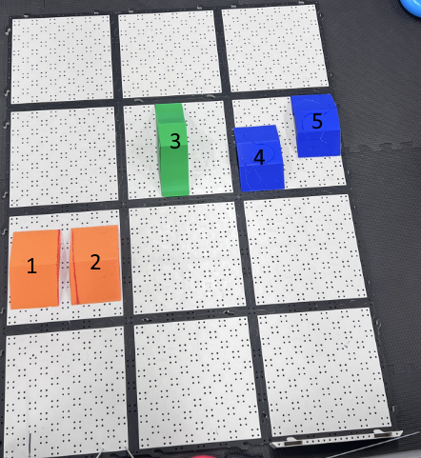

1 & 2: These are just 2 simple obstacle ramps for our bot to go over, so we can test how our bot can level when changing height of terrain.

3: This green wall makes the challenge slightly harder to complete as you have to go all around to complete the full course like shown in the final design photo below.

4 & 5: These are also ramps but they are staggered, to see how our bot can handle having one wheel on before the other.

Final Design Photo: 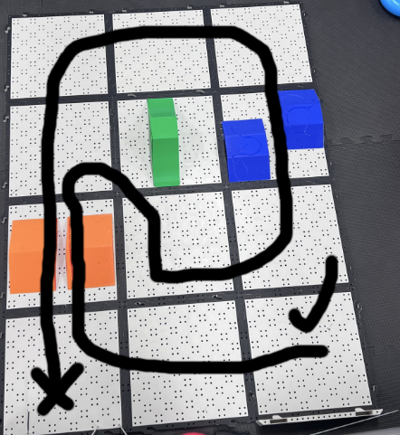

START FROM X, END AT CHECK MARK.